ADVANCED CYBERSECURITY CONCEPTS

CYBERSECURITY ARCHITECTURE

TASK1: Draw a network diagram for a music streaming app (like Spotify) showing how you would segment user traffic, admin traffic, and backend services using VLANs to isolate each group.
1. Network diagram for a music streaming app using VLANs
Aim: To divide network traffic into separate VLANs so that user traffic, admin traffic, and backend services remain isolated.
A music streaming application such as Spotify can use three separate VLANs.
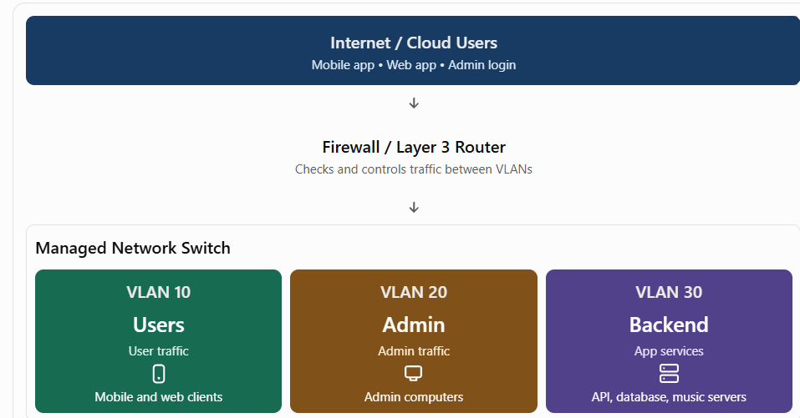
VLAN details
VLAN | Name | Example IP network | Purpose
VLAN 10 | User VLAN | 192.168.10.0/24 | User app and web traffic
VLAN 20 | Admin VLAN | 192.168.20.0/24 | Admin and management access
VLAN 30 | Backend VLAN | 192.168.30.0/24 | API servers, databases and music services

How it works:
- Users connect through the user VLAN.
- Admins use a separate admin VLAN to manage the system.
- Backend servers are placed in the backend VLAN.
- The firewall controls communication between the VLANs.
- Users cannot directly access the admin network or database.

TASK2: Configure a sample IAM policy (in JSON format) that allows a user to read playlists but not modify or delete them in a cloud-based music app.<br><br><em><strong>Hint:</strong> Use AWS IAM syntax, and specify the allowed and denied actions clearly.</em>
Sample IAM policy (JSON)

{
"Version": "2012-10-17",
"Statement": [
{
"Sid": "AllowReadingPlaylists",
"Effect": "Allow",
"Action": [
"music:GetPlaylist",
"music:ListPlaylists"
],
"Resource": "*"
},
{
"Sid": "DenyPlaylistChanges",
"Effect": "Deny",
"Action": [
"music:CreatePlaylist",
"music:UpdatePlaylist",
"music:DeletePlaylist"
],
"Resource": "*"
}
]
}
Explanation
Policy action | Meaning
Allow | Gives permission to read playlists
Deny | Blocks creating, editing and deleting playlists
Resource | Specifies which resources the policy applies to

TASK3; Write a short scenario describing how an IDS (Intrusion Detection System) could detect suspicious activity in a Zomato-style food ordering platform, and explain what kind of alert it should generate.
Scenario
Suppose a food ordering platform has thousands of customers. An attacker tries to access customer accounts by entering many different passwords repeatedly.
The IDS monitors network traffic and detects an unusual number of login attempts from the same IP address.
How IDS detects the activity
- The IDS monitors incoming network traffic.
- It detects repeated login failures from one IP address.
- It compares the activity with normal traffic patterns or security rules.
- It identifies the activity as suspicious.
- It generates a security alert for the administrator.
Example IDS alert
Suspicious login activity detected
High
- Platform: Food Ordering Application
- Activity: Multiple failed login attempts
- Source: Suspicious IP address
- Risk: Possible brute-force attack
- Action: Notify security team and investigate

TASK4: Pick any cloud security tool (like AWS GuardDuty, Azure Security Center, or Google Security Command Center) and describe how you would use it to monitor for unauthorized access in a Flipkart-like e-commerce platform.
Scenario
Suppose a Flipkart-style shopping website stores customer information, product details, and order records in AWS.
An attacker gets access to a stolen employee password and tries to access customer information.
How GuardDuty helps
- Open the AWS Management Console.
- Search for GuardDuty.
- Open the GuardDuty service.
- Enable GuardDuty in your selected AWS region.
- GuardDuty starts analyzing supported security data sources, such as AWS CloudTrail management events, VPC Flow Logs and DNS logs.
- Open the Findings section.
- Review any suspicious activity detected by the service.

Example security findings
Suspicious activity | Possible risk
Unusual login location or activity | Stolen account credentials
Unusual API calls | Unauthorized access
Suspicious network communication | Possible malware or compromised server
Unusual data access patterns | Possible data theft
Example alert
GuardDuty Security Finding
High severity
Possible unauthorized access detected
An IAM user is making unusual API requests from an unexpected location.
Recommended action:
- Investigate the IAM user's activity.
- Disable or rotate compromised credentials if necessary.
- Review permissions and enable MFA.
- Check related CloudTrail events.

TASK5: Use ChatGPT to generate a checklist of at least 7 steps for designing a secure architecture for a social media app (like Instagram) that combines VLANs, IDS/IPS, IAM, and cloud security tools. Paste the checklist and mention one thing you would add or change based on your own understanding.

Secure architecture checklist

- Divide user, admin and backend traffic into separate VLANs.
- Use firewalls to control communication between network segments.
- Install IDS to detect suspicious network activity.
- Use IPS to block known malicious traffic.
- Apply IAM policies and give users only the permissions they need.
- Enable MFA for administrators and important accounts.
- Encrypt sensitive data during storage and transmission.
- Use cloud security tools such as AWS GuardDuty to detect threats.
- Enable logging and monitor user activity regularly.
- Take regular backups and test data recovery.
- Update servers, applications and security software regularly.

One thing I would add based on my understanding
I would add regular security testing and vulnerability scanning to this architecture. It helps find security weaknesses in the application before attackers can misuse them.
Short explanation
A secure social media application should separate network traffic using VLANs, monitor threats using IDS/IPS, control access using IAM, and use cloud security tools for continuous monitoring. Encryption, MFA, backups and regular security testing provide additional protection.

